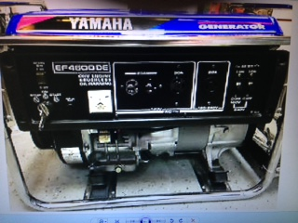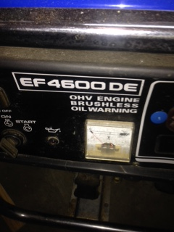
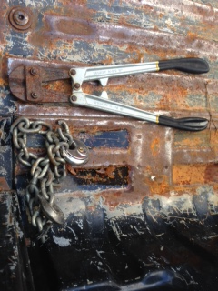
REWARD: Stolen Yamaha Generator
11-24-18 from my truck in East Ridge. Jim Winters Call 698-5050
S# 7RG220719 JIMWINTERS@COMCAST.NET

